**Black Jack**

**Developer: Ahmad okde**

**Course:** [2020_Summer_CSC_CIS_17a](https://github.com/ahmadokde/2020_Summer_CSC_CIS_17a)

Contents

Overview 3

Project Description 3

Number of players 3

The Pack 3

Object of the game 4

Card Values 4

Playing Options 4

Steps: 6

Inspiration 7

Black Jack Probabilistic AI Project 7

Technology: 8

Data Structure: 8

Display 9

Menu 9

Output Screenshots: 11

Menu Option 11

Main Game 11

Final result: 12

Limitations: 13

# Overview

## Project Description

**“Game of Black Jack”, also known as 21** is a classic card game that pits player versus dealer. It is a game of luck and strategy. At the start of a Blackjack game, the players and the dealer receive two cards each. The players' cards are normally dealt face up, while the dealer has one face down (called the hole card) and one face up. The best possible Blackjack hand is an opening deal of an ace with any ten-point card.

## Number of players

Minimum one and at most five players can play this game.

## The Pack

Blackjack is played with a standard international deck of cards with the Jokers removed, leaving 52 cards. In addition, the dealer uses a blank plastic card, which is never dealt, but is placed toward the bottom of the pack to indicate when it will be time for the cards to be reshuffled.

# Object of the game

Each participant attempts to beat the dealer by getting a count as close to 21 as possible, without going over 21.

## Card Values

When playing Blackjack the numeral cards 2 to 10 have their face values, Jacks, Queens and Kings are valued at 10, and Aces can have a value of either 1 or 11. The Ace is always valued at 11 unless that would result in the hand going over 21, in which case it is valued as 1.

Any hand with an Ace valued as 11 is called a ‘**soft**’ hand. All other hands are ‘**hard**’ hands.

## Playing Options

**Stand** – If the player is happy with the total they’ve been dealt they can stand, taking no further action and passing to the next player. The player can take this action after any of the other player actions as long as their hand total is not more than 21. The hand signal to Stand is waving a flat hand over the cards.

**Hit** – If the player wishes to take another card they signal to the dealer to by scratching the felt beside their hand or pointing to their hand. A single card is then played face up onto their hand. If the hand total is less than 21 the player can choose to Hit again or Stand. If the total is 21 the hand automatically stands. If the total is over 21 the hand is bust, the player’s bet is taken by the house and the turn to act passes to the next player.

**Double Down** – If the player considers they have a favourable hand, generally a total of 9, 10 or 11, they can choose to 'Double Down'. To do this they place a second wager equal to their first beside their first wager. A player who doubles down receives exactly one more card face up and is then forced to stand regardless of the total. This option is only available on the player's two-card starting hand. Some casinos will restrict which starting hand totals can be doubled.

**Split** – If the player’s first two cards are of matching rank they can choose to place an additional bet equal to their original bet and split the cards into two hands. Where the player chooses to do this the cards are separated and an additional card is dealt to complete each hand. If either hand receives a second card of matching rank the player may be offered the option to split again, though this depends on the rules in the casino. Generally the player is allowed a maximum of 4 hands after which no further splits are allowed. The split hands are played one at a time in the order in which they were dealt, from the dealer's left to the dealer's right. The player has all the usual options: stand, hit or double down. Some casinos restrict the card ranks that can be split and may also restrict the option to Double after splitting a pair.

A player who splits Aces is usually only allowed to receive a single additional card on each hand. Normally players are allowed to split two non-matching 10-value cards, for example a King and a Jack. However, some casinos restrict the splitting of ten value cards to pairs of the same rank (two Jacks for instance). It should be noted in any case that splitting 10's is almost always a poor play for the player. If Aces are split and the player draws a Ten or if Tens are split and the player draws an Ace, the resulting hand does **not** count as a Blackjack but only as an ordinary 21. In this case the player's two-card 21 will push (tie with) dealer's 21 in three or more cards.

**Surrender** – Some casinos allow a player to surrender, taking back half their bet and giving up their hand. Surrender must be the player's first and only action on the hand. In the most usual version, known as Late Surrender, it is after the dealer has checked the hole card and does **not** have a Blackjack. It has become increasingly rare for casinos to offer the surrender option.

## Steps:

1. The user loads the game in the console window.
2. A menu is displayed showing choices for Play game, display player statistics and exit.
3. If user chooses to play game, he will be prompted for name. default board size is 10x10. And then boards will be populated with ships. User will be asked for coordinates of grid and then game continues.
4. If user chooses to display player statistics, a file "winners.bin" will be looked if it exists. If file found, all lines will be printed from the file, which contains players win and lose statistics.

# Inspiration

## Black Jack Probabilistic AI Project

Blackjack has always been a fun and most popular card game. Blackjack has been a high-profile target for advantage players since the 1960s. Advantage play is the attempt to win more using skills such as memory, computation, and observation. It is a comparing card game between one or more players and a dealer, where each player in turn competes against the dealer. Players do not compete against each other. It is played with one or more decks of 52 cards, and is the most widely played casino banking game in the world

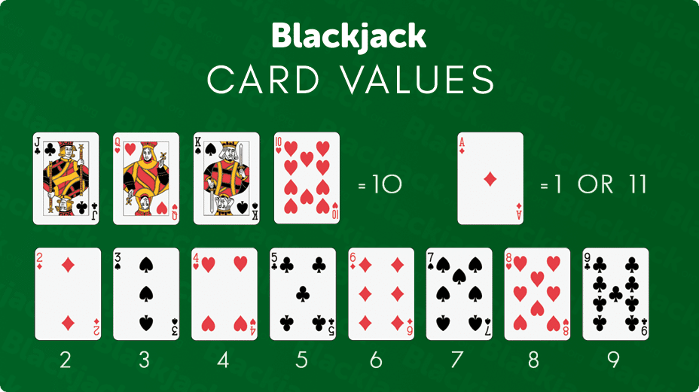

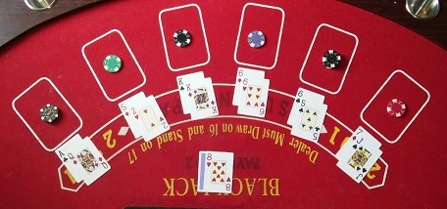

# Technology:

## Data Structure:

An integer pointer is used to store deck of cards. Deck size is 52. Number of maximum players is 5, and each player is deal 12 cards.

Enum status is declared which stores different status values.

enum status { Not_Used = -1, FIRST, HIT, SURRENDER, STAND, DOUBLE, BUST };

Deck of cards is initialized with 52 cards where 4 suits are there: Club, Diamond, Spades and heart. 1 to 13 ranks are used for each card where 1 for ace, 11 for jack, 12 for queen and 13 for king. After initializing the deck, the deck is shuffled. All hands are initially set as not_used.

A binary file is used to store winners and losers of every game. Every time, game is over, winners and losers are written to this file. A menu option is provided to user to view this file.

# Display

## Menu

When user starts the game, a menu is displayed to the user. Menu has 3 options: 1 – play game, 2 – display players statistics and 0 – exit. If user chooses option 1, game will start. If user chooses 2, contents of binary file “winners.bin” will be displayed. If user chooses 0, the game will terminate.

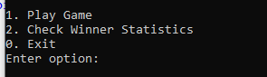

When user chooses to play name, number of players will be asked and then user will need to input their names.

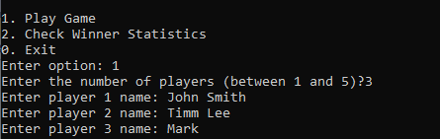

Then user starts to play game.

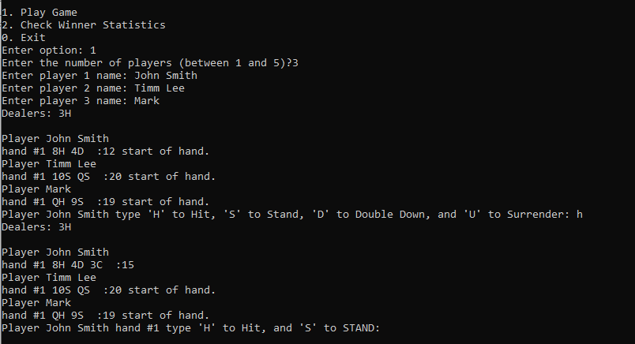

# Output Screenshots:

## Menu Option



## Main Game

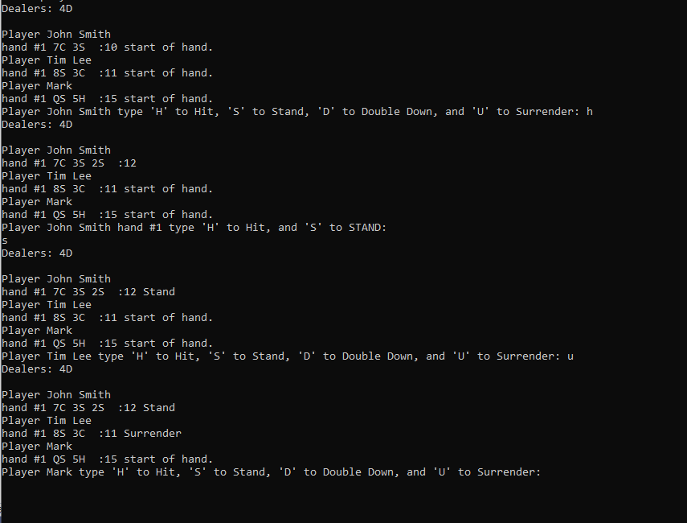

## Final result:

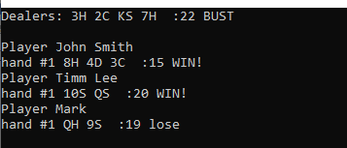

# Limitations:

1. The CLI interface can be difficult to understand at a glance.
2. It is difficult to understand as GUI for cards is not here.